**Lesson 19: Volume of Rectangular Prisms**

**Do Now:**

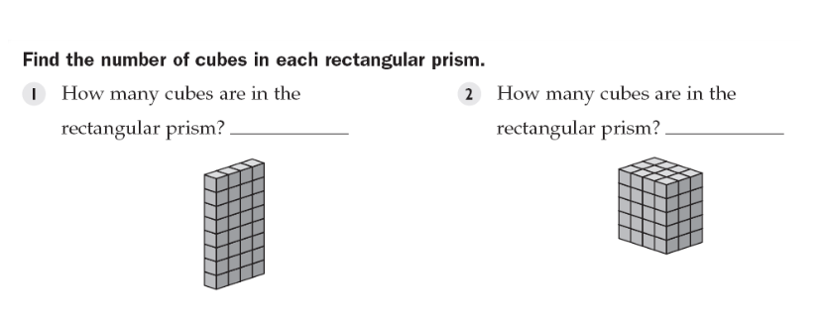

**Independent Practice:**

Original volume: (2 in)(5 in)(3 in) = 30 in3

New volume: (22 in)(52 in)(32 in) = 900 in3.

Assume the side of the cube is 2 inches.

Before the cut: V = (2 inches)3 = 8 inches3

After the cut: V = (1 inches)3 = 1 inches3. Volume is divided by 8.

V = (4 cm)(6 cm)(3 cm) = 72 cm3

V = Bh = (6 cm)(6 cm)h = 72 cm3

36 cm2 * h = 72 cm3; h = 2 cm

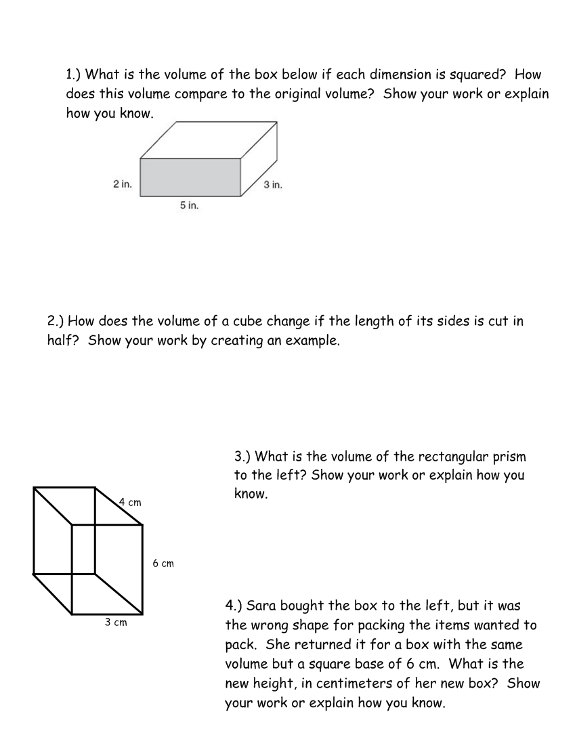

**Closure:**

x = 20

x = 32

x = 7

